**EXPERIMENT-4:**

4.Jenkins installation and setup,explore the environment

**ON WINDOWS :**

* The pre-requisites for jenkins are java(11 or 17 or 21) and maven.
* Download and install java from

<https://www.oracle.com/in/java/technologies/downloads/>

* Download and install maven from

<https://maven.apache.org/download.cgi>

* Download jenkins from

<https://www.jenkins.io/download/>

* Click on the downloaded file
* Click on Next to setup wizard

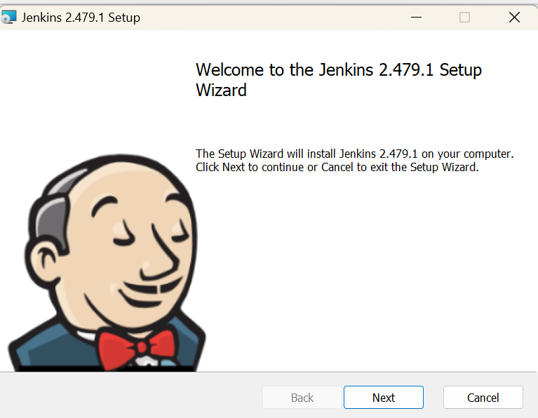

* Click on next to set the destination folder

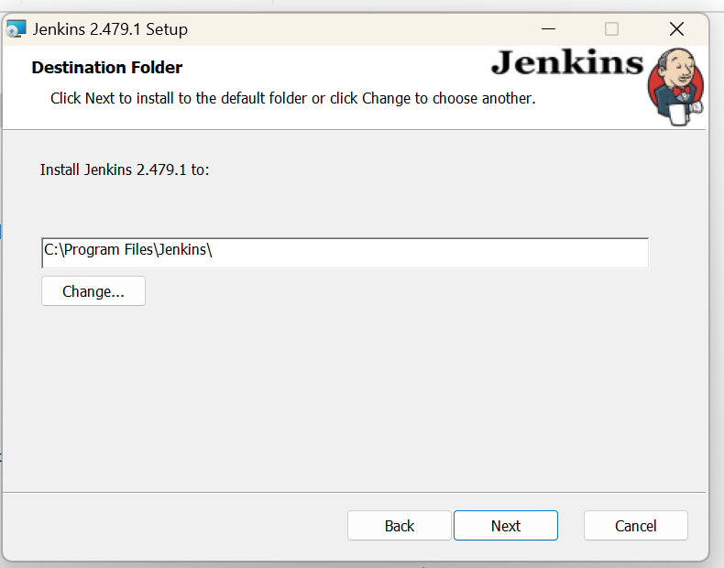

* Select logon typeas local system and click on next

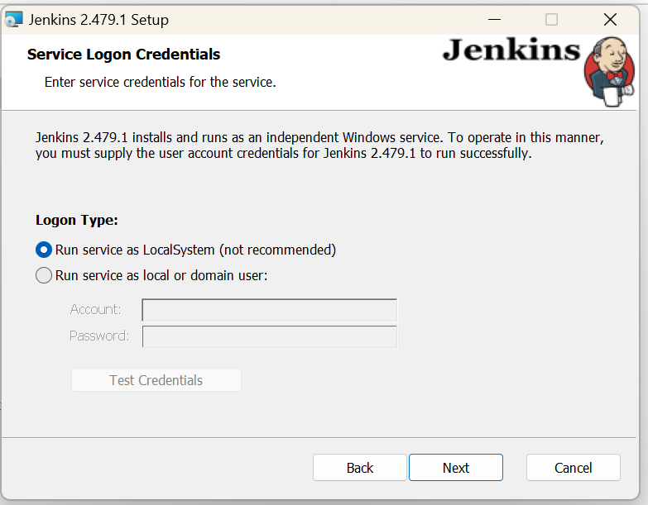

* Set a port number and test the port then click on next

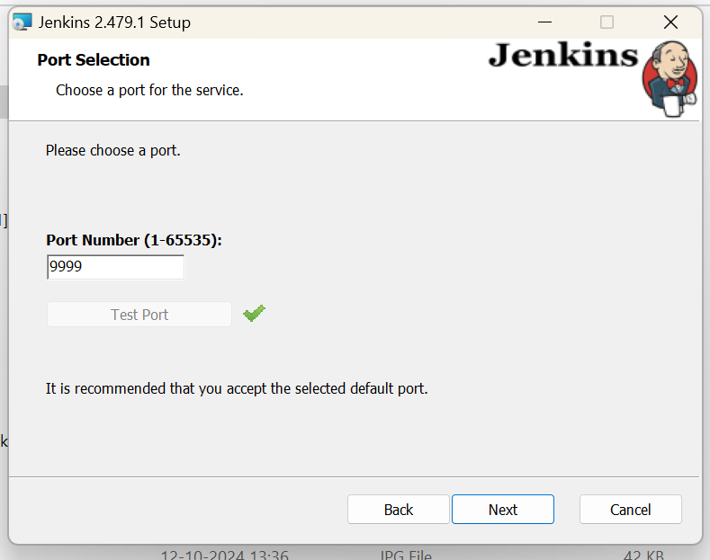

* Click on change to set java path

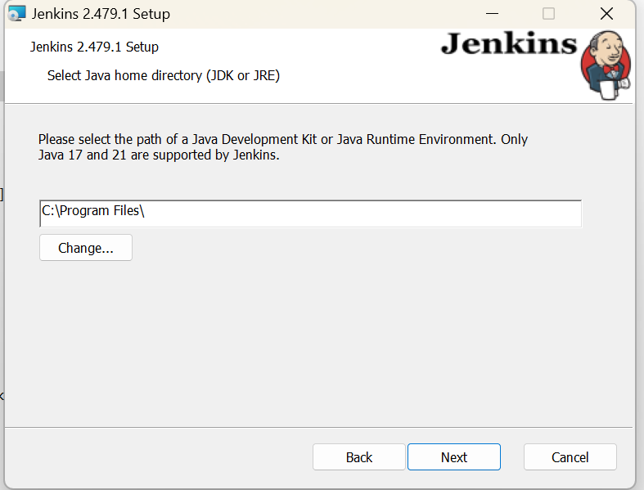

* Select jdk 11 or 17 or 21

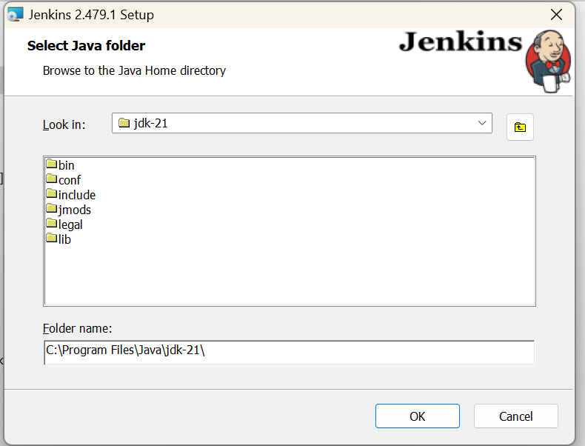

* 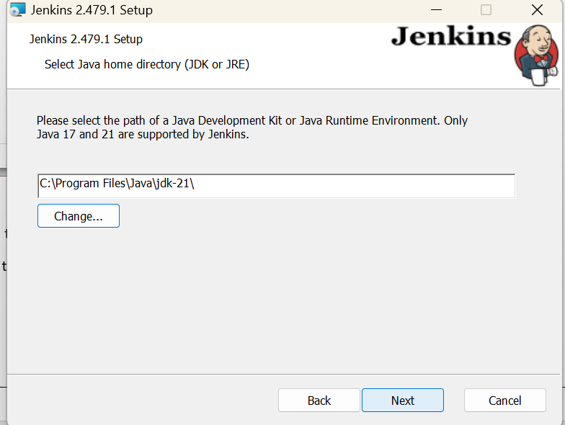Click on next to continue
* Click on next to continue custom setu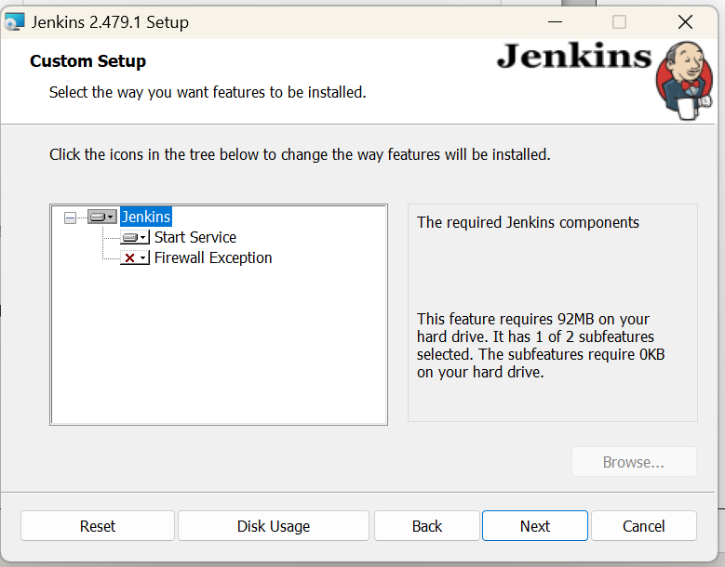p
* Click on install

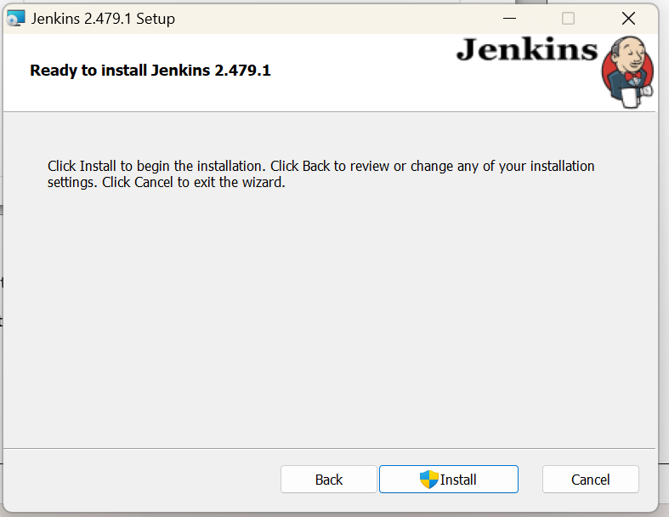

* Click on finish

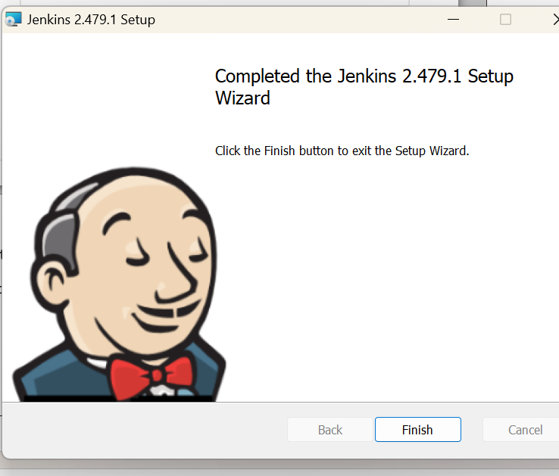

* In browser open localhost:999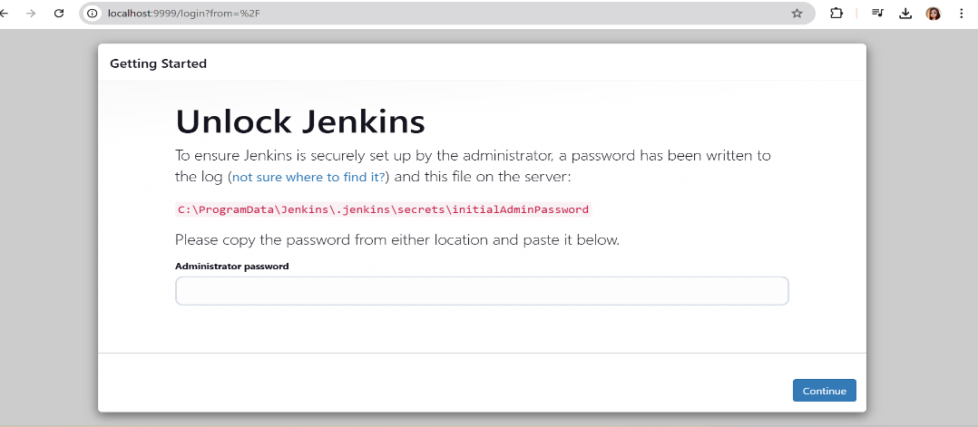9
* Copy and paste the path in new tab to get password

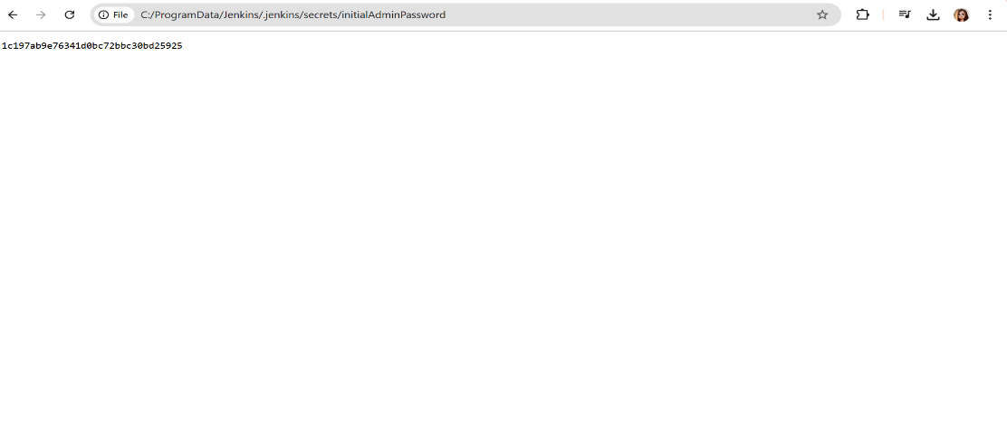

* 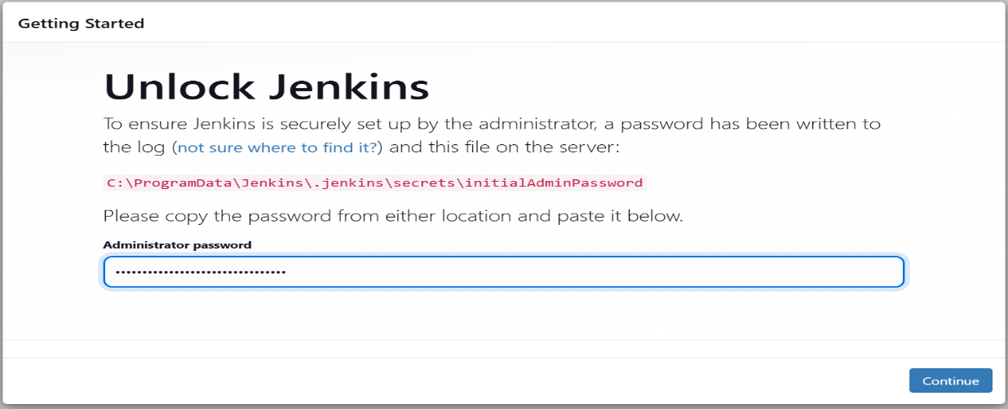Paste the password here to unlock jenkins
* 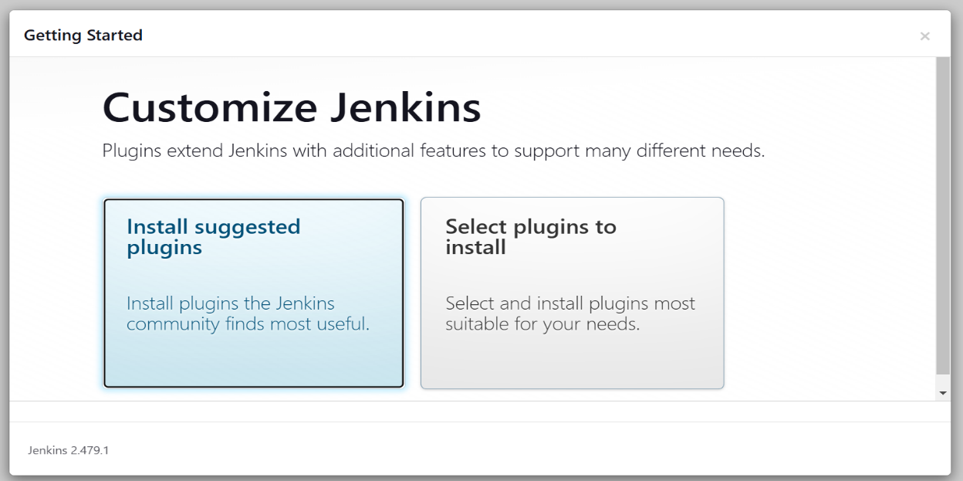Click on install suggested plugins
* 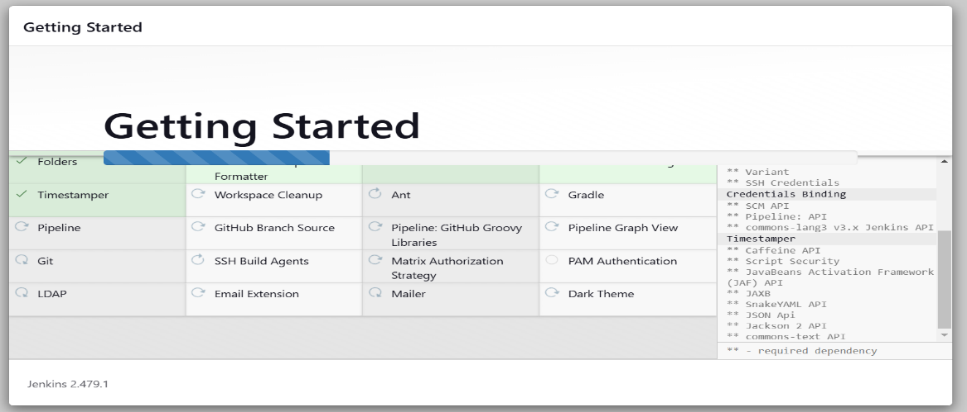Plugins will get installed
* Configure the jenkins

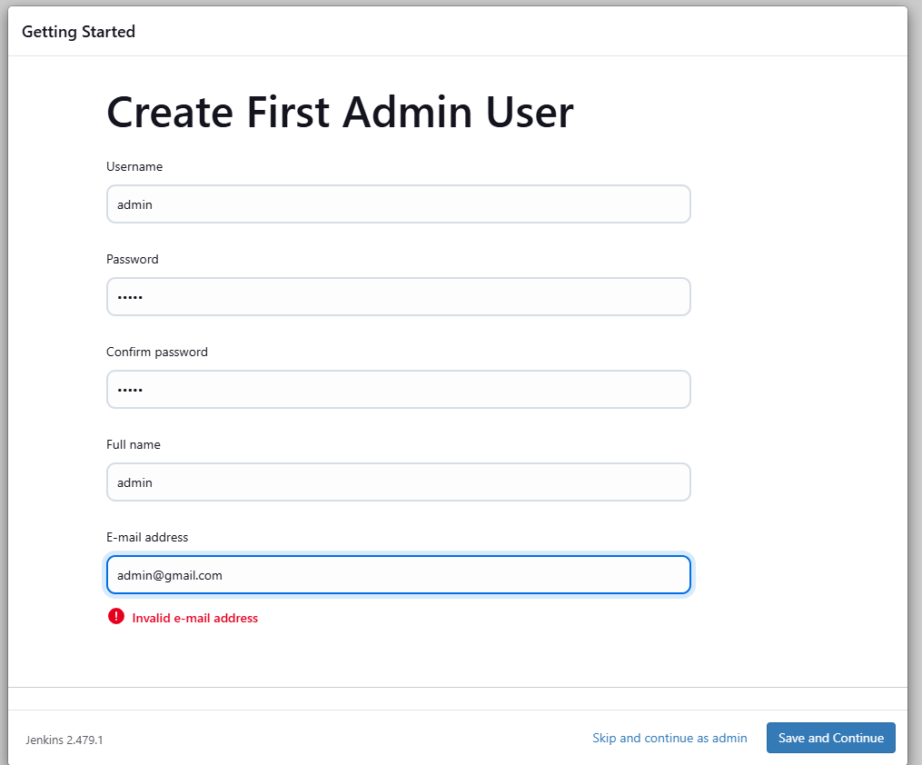

* Click on save and finish

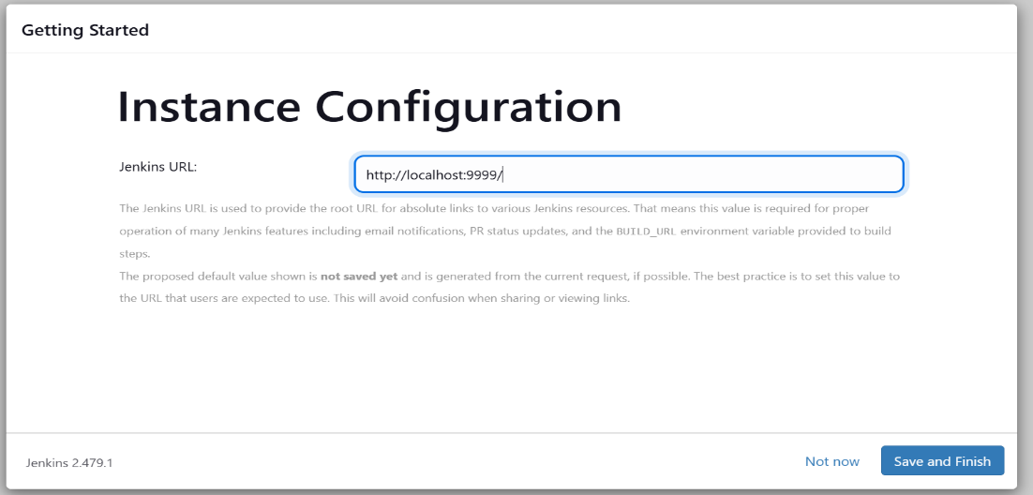

* Click on start using jenkins

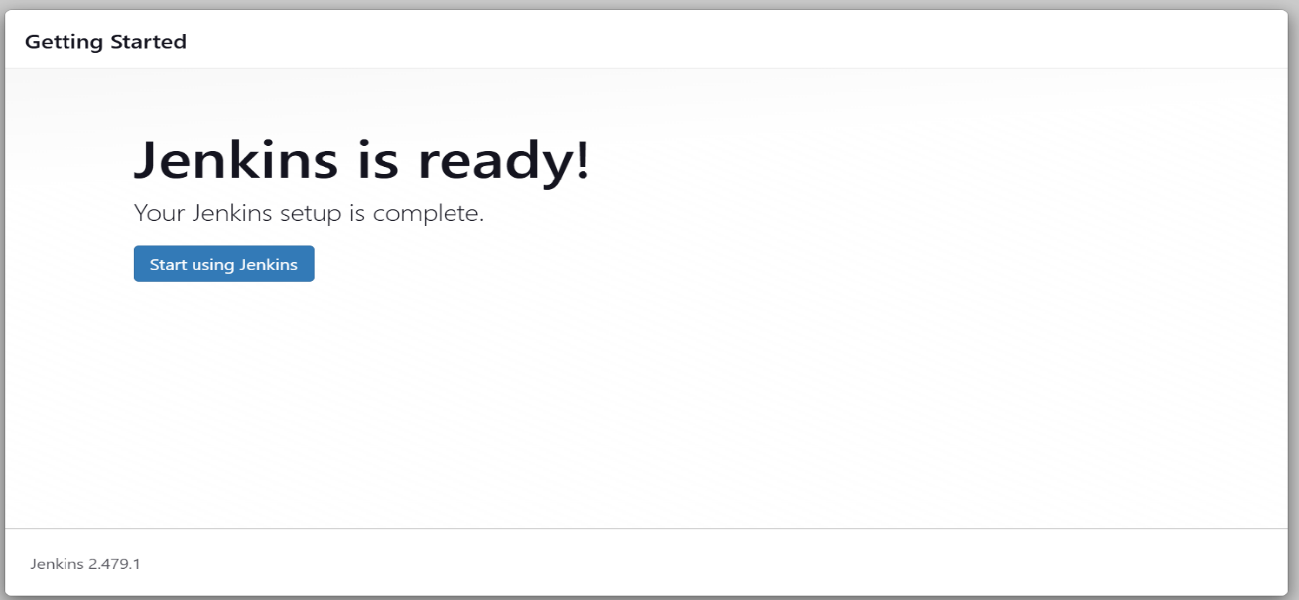

* 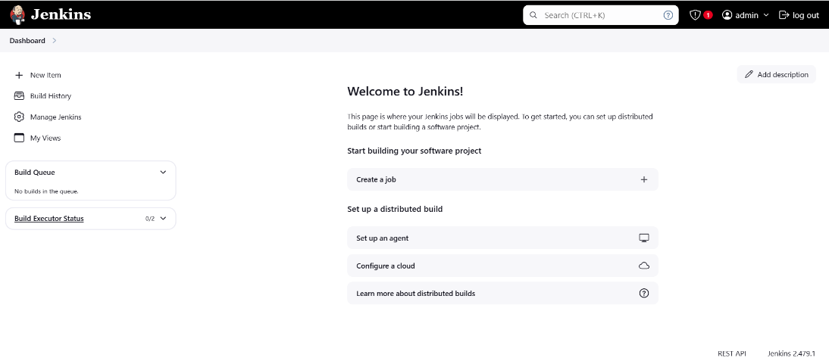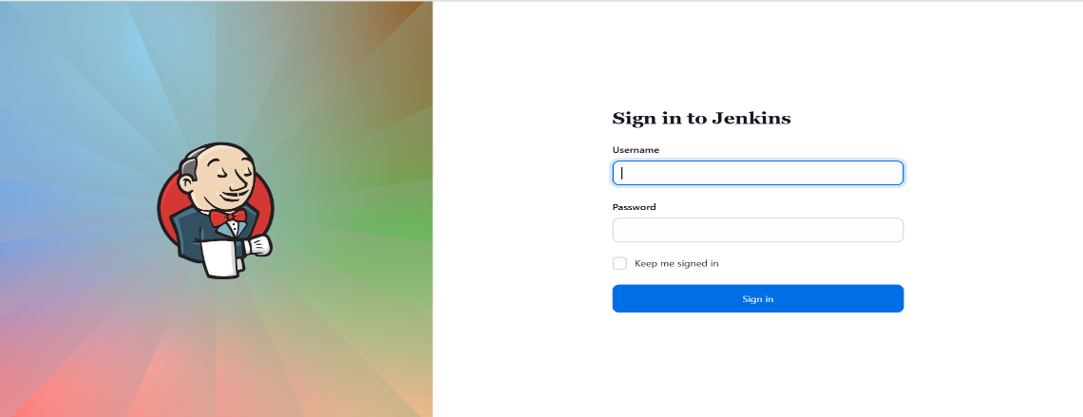Jenkins is ready to use

**ON UBUNTU :**

* Login on to your aws account
* Create a ubuntu instance
* Start the instance
* Create a key pair and the pem file gets downloaded
* Open gitbash in the pem file location
* Paste the ssh client link of the instance
* Follow the commands to install jenkins
* sudo apt update
* java and javac for jre and jdk
* sudo apt install maven -y
* sudo wget -O /usr/share/keyrings/jenkins-keyring.asc \
* echo "deb [signed-by=/usr/share/keyrings/jenkins-keyring.asc]" \

https://pkg.jenkins.io/debian-stable binary/ | sudo tee \

/etc/apt/sources.list.d/jenkins.list > /dev/null

* sudo apt update
* sudo apt-get install jenkins
* sudo systemctl start jenkins
* sudo systemctl enable jenkins
* sudo systemctl status jenkins
* Add inbound rule in security of instance with port 8080
* In chrome jenkins instance public IP address:8080

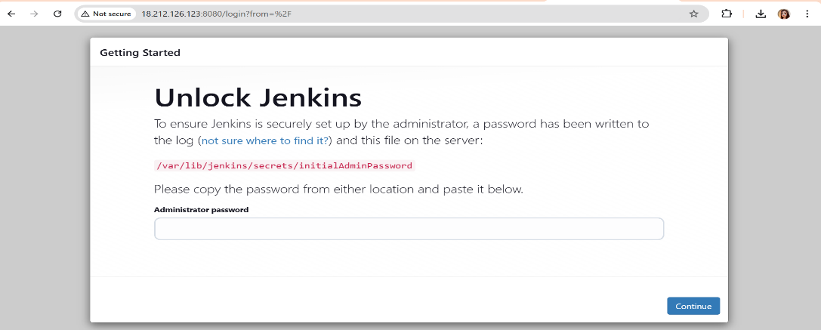

* Copy the path
* Run the following command in gitbash
* sudo cat /var/lib/jenkins/secrets/initialAdminPasswword
* Copy and paste the password in Administrator password

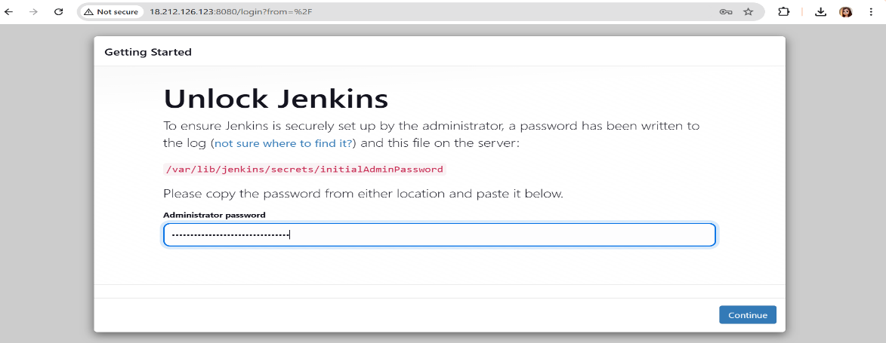

* Install suggested plugins

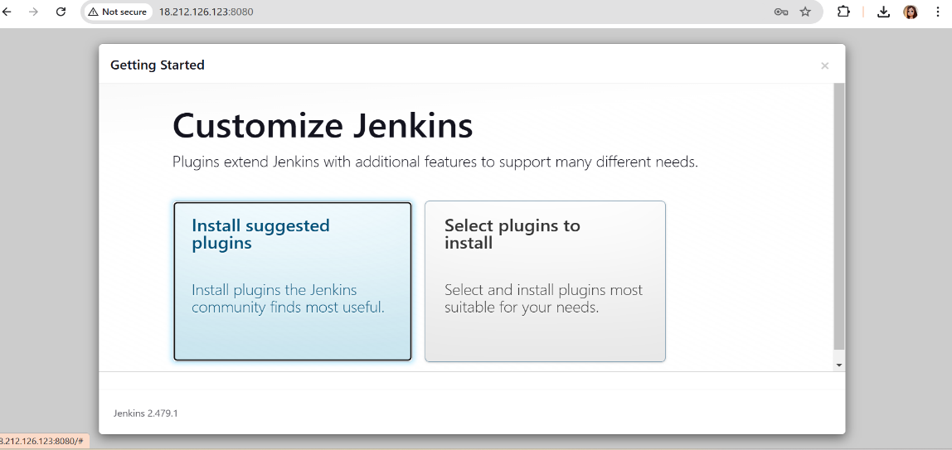

* 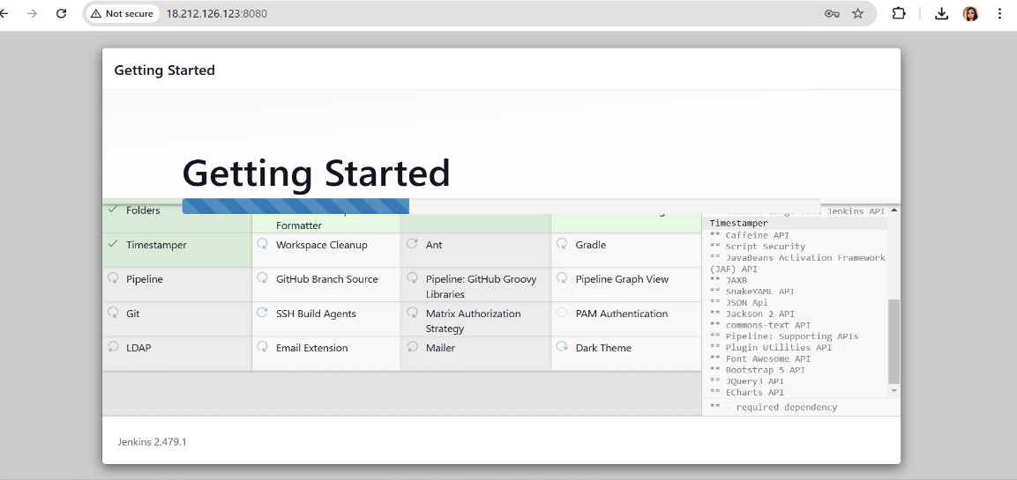The plugins gets installed
* Configure jenkins

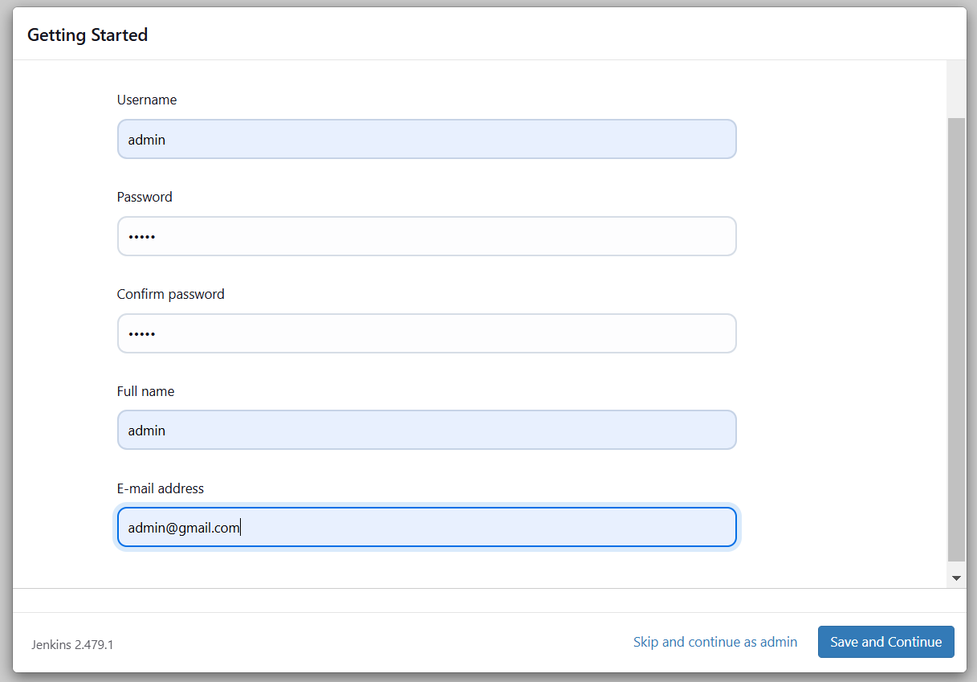

* 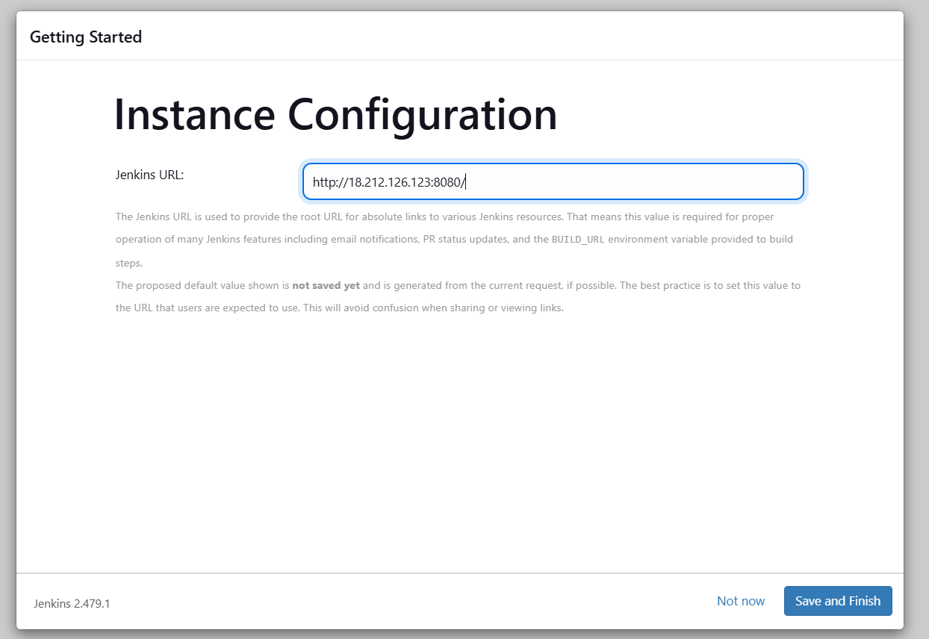Click on save and finish
* Click on start using jenkins

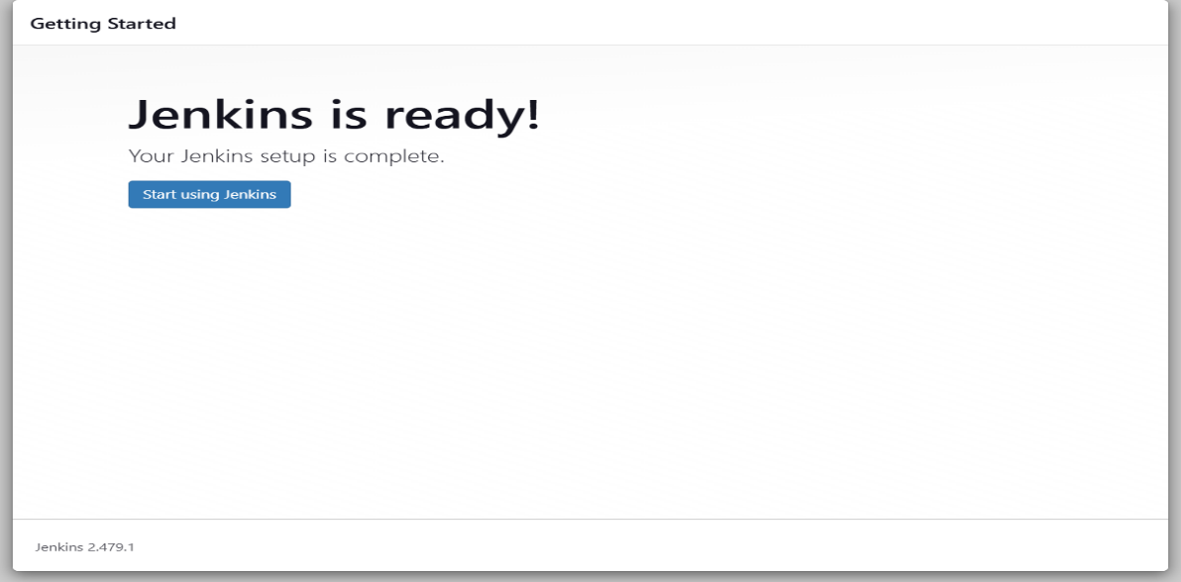

* 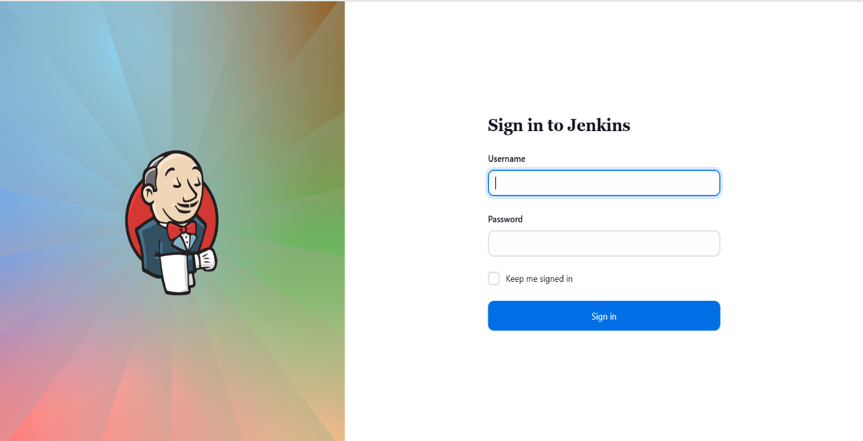Jenkins is ready to use

